TAIF UNIVERSITY

Fall 2017/2018



**An Educational IOS app For kids using augmented reality**

A Senior Project Submitted to

The College of Computers and Information Technology

in Candidacy for the Degree of

Bachelor in Computer Science

**Students’ Property Right Declaration**

I hereby declare that the work in this capstone project at Taif University is my own except for quotations and summaries which have been duly acknowledged. This work with the title "an educational IOS app for kids using augmented reality" has not been accepted for any degree and is not concurrently submitted for award of other degrees. It is the sole property of Taif University and it is protected under the intellectual property right laws and conventions. Authors:

Name: _____________________ Signature: ____________________ Date:___________

Name: _____________________ Signature: ____________________ Date: ___________

Name:_____________________ Signature: ____________________ Date: ___________

Name_____________________ Signature: ____________________ Date: ____________

Supervisor:

Name: _____________________ Signature: ____________________ Date: ___________

**Students Anti-Plagiarism Statement**

I hereby declare this report is my own work except for properly referenced quotations, and contains no plagiarism; it has not been submitted previously for any other assessed unit on this or other degree courses. I have read and understood the School's rules on assessment offences which are available in the Taif University Handbook.

أنا الممضي أسفله أشهد أن هذا التقرير هو عملي الخاص أنا ومجموعة الطلبة المذكورة أسماؤهم بأول هذا التقرير ما عدا ما هو مذكور مصادره صراحة وأنه لا يحتوي على محتويات منقولة بدون عزوها لكاتبها الأصلي. وأشهد أن هذا العمل لم يسبق أن استخدم كعمل رسمي بمقررات أخرى بهذه الكلية أو غيرها.

أشهد أني اطلعت على قوانين الكلية الخاصة بتقييم الطلبة الموجود في بالكتاب التقديمي للجامعة.

Authors:

Name: _________________ Signature: _________________ Date: _________________

Name: _________________ Signature: _________________ Date: _________________

Name: _________________ Signature: ____________________ Date: _______________

Name_________________ Signature: ____________________ Date: ________________

**Abstract**

Our proposed system is based on two important principles: the implementation of an application that uses augmented reality technology, as well as its important goal of teaching children the names and sounds of animals. Due to the huge progress in IOS applications, we have chosen the latest technologies that developers are working on for Android or iPhone applications, which is the augmented reality technology.

Our application supports this technique so that it can be used to teach children the names and sounds of animals with a 3D view of the animal using the mobile camera so that the camera focuses on a 2D graphic or picture of the animal, then the application processes this and shows us or the child the shape of the animal above the real picture in 3d shape. The image is accompanied by the name of the animal and a sound clip that matches the animal's sound will be played. Taking into account that we add as much as possible all animal images and sounds within the database.

**ملخص مقترح البحث ( عربي )**

إن نظامنا المقترح يقوم على أساسين مهمين وهما تنفيذ تطبيق يستخدم تقنية الواقع المعزز بالإضافة لهدفه الهام وهو تعليم الأطفال أسماء الحيوانات وأصواتها. ونظراً للتقدم الهائل بتطبيقات الأندرويد فقد اخترنا أحدث التقنيات التي يتم العمل عليها من قبل المطورين لتطبيقات الأندرويد أو الأيفون وهي تقنية الواقع المعزز. فتطبيقنا يدعم هذه التقنية بحيث يستخدمها لتعليم الأطفال أسماء الحيوانات وأصواتها مع طريقة عرض ثلاثية الأبعاد للحيوان وذلك باستخدام الكاميرا الخاصة بالموبايل بحيث تركز الكاميرا على رسمة أو شكل ثنائي البعد للحيوان فيعالج التطبيق ذلك ويظهر لنا أو للطفل شكل الحيوان فوق الصورة الحقيقية وبأسلوب ثلاثي الأبعاد ويرافق الصورة اسم الحيوان ويتم تشغيل مقطع صوت يطابق صوت الحيوان. مع الاخذ بعين الاعتبار أن نضيف قدر الإمكان كافة صور الحيوانات وأصواتها ضمن قاعدة البيانات.

**Table of Contents**

Contact information………………………………………………………………………………………………….……..i

Students property Right Declaration……………………….……………………………………………………….ii

Students Anti-Plagiarism Statement……………………….……………………………………………………….iii

Abstract ….....................................................................................................................................iv

List of Tables................................................................................................................................viii

List of Figures...............................................................................................................................ix

List of Acronyms (Abbreviations) and Symbol……….………………………………………………………….x

**Chapter 1: Introduction** 2

**1.1** **Overview and Problem Background:** 2

**1.2** **Problem Statement:** 3

**1.3** **Objectives:** 3

**1.4** **Scope:** 3

**1.5 Scenario** …………..……………………………….……………………………………………………………….….4

**1.6** **Contributions/Significance of the Project:** 6

**1.7 Expected Benefits:** 6

**Chapter 2: Planning:** 8

**2.1 Approach & Methodology:** 8

**2.1.1 Waterfall model:** ………………………………………………….…………………………………………………………..8

**2.2 Feasibility Study**...……………………………………………………………………………………………………………..……9

**2.2.1 Questionnaires:** 9

**2.2.1.1 Questionnaire in English**……………………………………………………………………..……9

**2.2.1.2 Questionnaire in Arabic**………………………….…………………………………………….11

**2.2.2 Questionnaire Validation**…………………………………….………………………………………………12

**2.2.3 Questionnaire Result**…………………………………………………………………………………………….13

**2.2.4 Some Audience Suggestions**…………………….………………………………………………………15

**2.3 Literature Review** ………………………………………….….…………………………………….…………….16

**2.3.1 FETCH! Lunch Rush – an augmented reality math game:** 16

**2.3.2 Quiver – 3D coloring app:** ………………………………………………………………………….16

**2.3.3 Zoo Burst app - 3D Storybooks with extra Augmented Reality:** 17

**2.3.4** **Comparison of Related Works** 18

**2.4 Activity plan** ………………………………………………………………………………………………………….19

**2.5 Tools:** 20

**2.5.1 Software Tools**……………………………………………………………………………………………………20

**2.5.1.1 Vuforia**………………………………………………………………………………………………………20

**2.5.1.2 Unity 3D** ……………………………………………………………………………………………………..21

**2.5.1.3 Xcode**…………………………………………………………………………………………………………22

**2.5.1.4** **Visual paradigm v10.00**………………………………………………………………………22

**2.5.2 Hardware**………………………………………………………………………………………………………………22

**Chapter 3: Analysis** 244

**3.1 Functional and Non- Functional Requirements:** 24

**3.1.1 Functional Requirement**…………………………………………………………………………………24

**3.1.2 Non- Functional Requirements:**  27

**3.2 ERD Diagram (Entity Relationship Diagram):** 28

**3.3 Database Schema** 29

**3.4 Use Case Diagram:** 30

**3.4.1 Kid and Admin Use Case Digram:** 310

**3.4.2 Use Case Description:** ………………………………………………………………………………….31

**3.5 Class Diagram:** 36

**3.6 Sequence Diagram** 37

**3.6.1 kid sign in:** 37

**3.6.2 show 3D animal:** 38

**3.6.3 show list of shown animals:** 39

**3.6.4 Admin Tool:** 40

**Chapter 4: Interfaces Design** 42

**4.1 User Interfaces:** 42

**Chapter 5 Conclusion and Future Works:** 44

**5.1 Conclusions:** 44

**5.2 Future Works:** 44

**References**: 45

**List of Tables**

**Table (2.1) : Questionnaire validation 12**

**Table (2.2) comparing table of related apps with ours 18**

**Table (3.1): Sign up Use Case ……………………………………………………………………….…31**

**Table (3.2): Sign in Use Case ………………………………………………………………………..…31**

**Table (3.3): focus camera on 2D picture Use Case ………………………………………….…32**

**Table (3.4): Show 3D photo of Animal Use Case ……………………………………………….32**

**Table (3.5): Clicks on the 3D photo for rotating it Use Case …………………………….…33**

**Table (3.6): Show list of latest shown animals Use Case ……………………………………33**

**Table (3.7): Adding new 2D animal's photo Use Case ……………………………………..…34**

**Table (3.8): Adding 3D images with sound Use Case …………………………………….…..34**

**Table (3.9): Training the code on new photos Use Case ……………………………………..35**

**List of Figures**

**Figure 1.1 work Scenario of our project** 4

**Figure 2.1 Waterfall Model** 8

**Figure 2.2 Activity plan** 19

**Figure 3.1 ERD Diagram** 28

**Figure 3.2 Database Schema** 29

**Figure 3.3 Use case Diagram** 30

**Figure 3.4 Class Diagram** 36

**Figure 3.5 Kid sign in diagram** 37

**Figure 3.6 show 3D animal diagram** 38

**Figure 3.7 show list of shown animals diagram** 39

**Figure 3.8 admin Tool diagram** 40

**Figure 4.1 User Interfaces** 42

**List of Acronyms (Abbreviations) and Symbol**

**FR** … Functional Requirement.

**NFR** … Non-Functional Requirement.

**PK** … Primary Key

**FK** … Foreign Key

**ERD** … an entity-relationship diagram (ERD) is a type of data modeling that shows a graphical representation of objects or concepts within an information system.

**UML** … The Unified Modeling Language (UML) is a general-purpose modeling language in the field of software engineering.

**Chapter 1: INTRODUCTION**

# **Chapter 1: Introduction**

## **Overview and Problem Background:**

## 

Augmented reality may not be as exciting as a virtual reality rollercoaster ride; however, it may prove to be a very useful tool in our everyday lives. It holds this potential because it brings elements of the virtual world, into the real world, enhancing the things we see, hear, and feel. Among the other reality technologies, augmented reality lies in the middle of the mixed reality spectrum, being between the real and virtual world. [1][2]

Because there are many electronic ways to teach the child, we choose an IOS app to teach the child names of animals and their sounds through AR implemented in our app, with a nice way to display the pictures of animals in 3D shape.

We want to build an educational IOS app; this app helps kids to know names of all animals and their sounds.

This app uses mobile’s camera for implementing augmented reality , so the kid or his parents hold the mobile , then open camera and direct the camera to any 2d picture on a paper or an wall.

Then the app displays the 3D image of this animal, its name above the image and runs the sound of this animal.

Augmented reality is a way of using the real and the virtual world by overlaying digital data on the real-world views. It requires a good understanding of image processing, for tracking markers on the image.

## **Problem Statement:**

To provide solutions to the problem mentioned before, this project is supposed to help kids to facilitate the education process of animals names and knowing about their sounds and shapes in Amusing way. It enables kids to focus on any 2D shape of animal , then the system displays the 3D shape of the animal with playing sound track of that animal's voice in a very easy and quick way.

## **Objectives:**

In this project, we aim to achieve the following objectives:

* Enable kids to know all the types of animals , their names and their shape in 3D manner.
* Help the kids in knowing how to say the name of each animal and hearing the sound of each one.
* the most important in this app that its aim in educating those kids
* Helping parents in one of many educational domains for kids.

## **Scope:**

The intended users of the system are all kids from all ages who need to take knowledge about animals' names and their sounds by using this app through device camera.

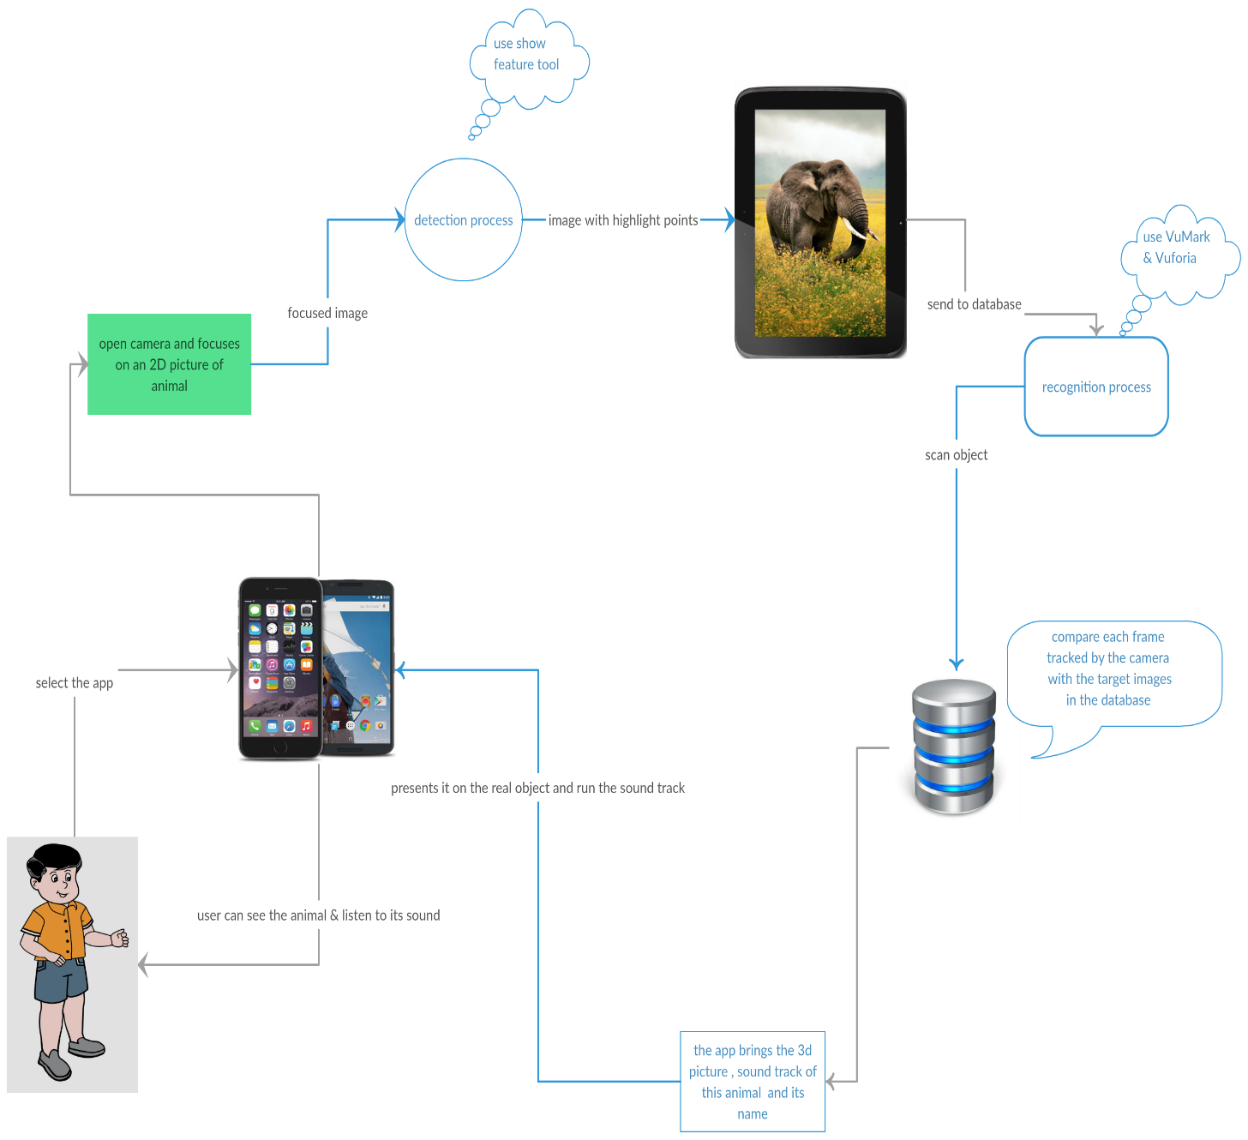**1.5 Scenario:**

**Figure 1.1 work Scenario of our project**

In this scenario, we explain the application of this project:

1. The kid Or User should select the app from the app list.
2. Open the camera, and let it focuses on the existed frame.
3. For each frame the app execute a detection process for it using show feature tool ( where the app has a database which contains all photos of animals in 2D type and Vuforia can determine the features of each photo as highlight points ).
4. The app runs the recognition process via Vumark & Vuforia and sends this processed photo (frame) captured by camera to the database, where the app will compare it with the images in database.
5. If there is a match, then the app returns the 3D picture of the same animal with its name, also the app brings the sound track of this animal.
6. Then the app presents the 3D image above the real 2D one and runs the sound track of this animal.
7. If there is no match, the app keep tracking each frame captured by the camera.

## **Contributions/Significance of the Project:**

## 

By the end of this project, we expect to obtain the following benefits:

* For facilitating the knowing process about animals.
* To reduce the time and effort needed to know these animals.
* To help the parents in learning their kids about the animals.

## **1.7 Expected Benefits:**

* Helping parents in teaching their kids.
* Teaching & Entertaining kids through this type of nice app that contains what the 3D shape of each animal and what its sound must be.
* Easy & entertained to use for any one.
* High accurate in results.
* Flexible system.
* Knowing animals through their 3D images and their voice helps the kid to remember them faster.

**Chapter 2: Planning**

# 

# 

# **Chapter 2: Planning:**

# **2.1 Approach & Methodology:**

# 

We used waterfall model to design our system is the traditional version and the classic approach of system development life cycle. It describes the sequential and linear development method. Waterfall methodology has clear objectives and goals for each phase of the system development life cycle.

It is very simple to understand and use.  In a waterfall model, each phase must be completed fully before the next phase can begin. This type of [software development model](http://istqbexamcertification.com/what-are-the-software-development-models/) is basically used for the for the project which is small and there are no uncertain requirements. At the end of each phase, a review takes place to determine if the project is on the right path and whether or not to continue or discard the project. In this model [software testing](http://istqbexamcertification.com/what-is-a-software-testing/) starts only after the development is complete.[6]

 **2.1.1** **Waterfall model:**

**Figure 2.1 Waterfall Model**

**2.2 Feasibility Study:**

## **2.2.1 Questionnaires:**

We designed a questionnaire using Google forms. The questionnaire is accessible from the following link:

<https://docs.google.com/forms/d/e/1FAIpQLScMZdhOYg4K5b-GWa_J13-w37xDvWfC5qF0gqyy8fVE_Ce_KQ/viewform>

We distributed our questionnaire electronically via e-mails and on social media.

**2.2.1.1 Questionnaire in English:**

**Recognize Of Animals:**

A questionnaire for "Recognize of Animals" iOS Application by using AUGMENTED REALITY technology.

**1.) Do you prefer using Augmented Reality Applications?**\*

1. Strongly Agree
2. Agree
3. Neutral
4. Disagree
5. Strongly Disagree

**2.) Do you prefer learning your kids with technology?** **\***

* Strongly Agree
* Agree
* Neutral
* Disagree
* Strongly Disagree

**3.) What is the age of your kid?** *



**4.) Do you prefer learning your kid the names of animals with knowing their sounds & their shapes with 3D way? \***

* Strongly Agree
* Agree
* Neutral
* Disagree
* Strongly Disagree

**5.) Do your kids have got any experience with application like this? \***

* Yes
* No

**6.) Do you have any suggestions?**

سال

**2.2.1.2 Questionnaire in Arabic:**

التعرف على الحيوانات

هذا الاستبيان لتطبيق آيفون يساعد الطفل بالتعرف على الحيوانات واشكالها وأصواتها باستخدام تقنية الواقع المعزز. وهي التكنولوجيا القائمة على عرض الأجسام الافتراضية والمعلومات في بيئة المستخدم الحقيقية لتوفر معلومات إضافية أو تكون بمثابة موجه له، وهو يكون عكس الواقع الافتراضي القائم على عرض الأجسام الحقيقية في بيئة افتراضية، وهي تقنية تدمج ما بين البيئة الحقيقية والافتراضية.

1.هل تفضل استخدام تطبيقات الواقع المعزز؟ *

موافق بشدة

موافق

محايد

غير موافق

غير موافق بشدة

2.هل تفضل تعليم اطفالك باستخدام التكنولوجيا؟ *

موافق بشدة

موافق

محايد

غير موافق

غير موافق بشدة

3.ما هو عمر أطفالك؟ *



إجابتك

4.هل تفضل تعليم طفلك اسماء الحيوانات ومعرفة اصواتها وأشكالها بطريقة عرض ثلاثية الأبعاد؟ *

موافق بشدة

موافق

محايد

غير موافق

غير موافق بشدة

5.هل لدى أطفالك تجربة سابقة لمثل هذه التطبيقات؟ *

نعم

لا

6.هل لديك أي اقتراحات؟

إجابتك



**2.2.2 Questionnaire Validation**

Table 2.1 shows the method for questionnaire validation, which we followed in this project. The method is called content validation as we linked our objectives with our questionnaire. We validated our questionnaire with two experts and made sure our questions are reported clearly.

|  |  |  |  |  |  |
| --- | --- | --- | --- | --- | --- |
| Objective | Questionnaire item (questions that are related to the objective) | Expert (1) | | Expert (2) | |
| Yes | No | Yes | No |
| Importance of AR | هل تفضل استخدام تطبيقات الواقع المعزز | ✓ |  | ✓ |  |
| Solve online education courses | هل تفضل تعليم طفلك اسماء الحيوانات ومعرفة اصواتها وأشكالها بطريقة عرض ثلاثية الأبعاد؟ | ✓ |  | ✓ |  |
| Facilitate education for kids | هل تفضل تعليم اطفالك باستخدام التكنولوجيا؟ | ✓ |  | ✓ |  |
| هل لدى أطفالك تجربة سابقة لمثل هذه التطبيقات؟ |

Table (2.1): Questionnaire validation

**2.2.3 Questionnaire Results:**

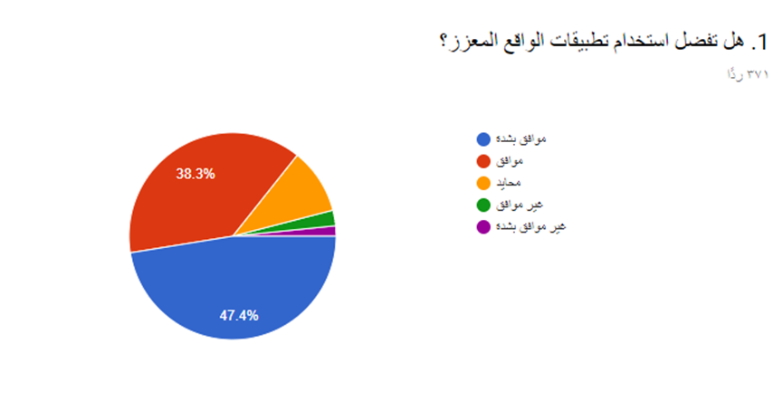

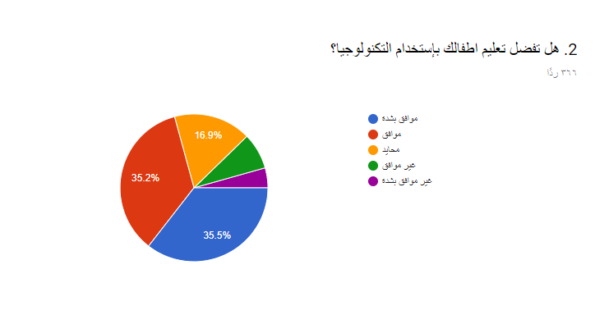

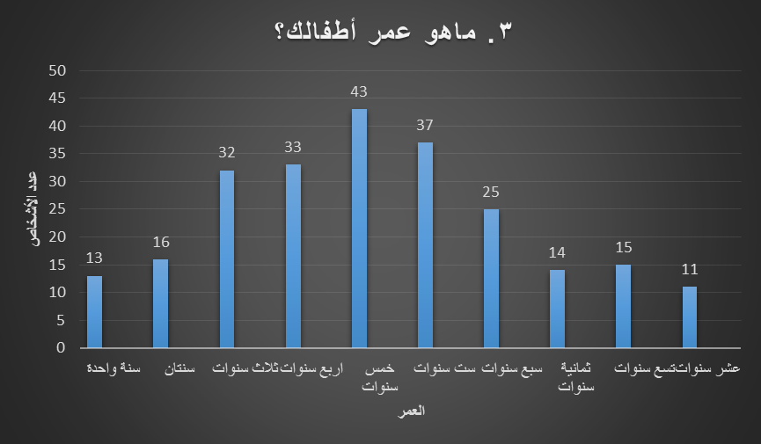

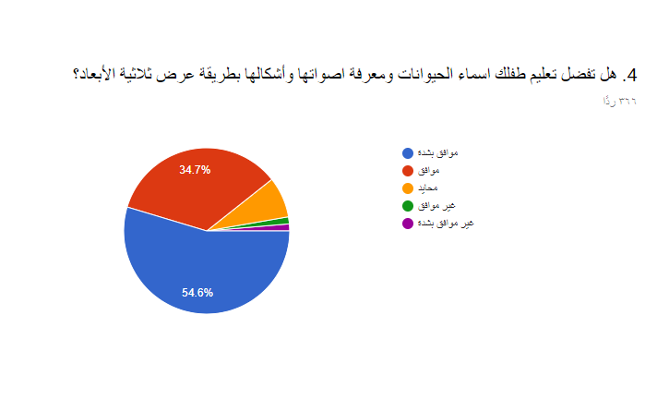

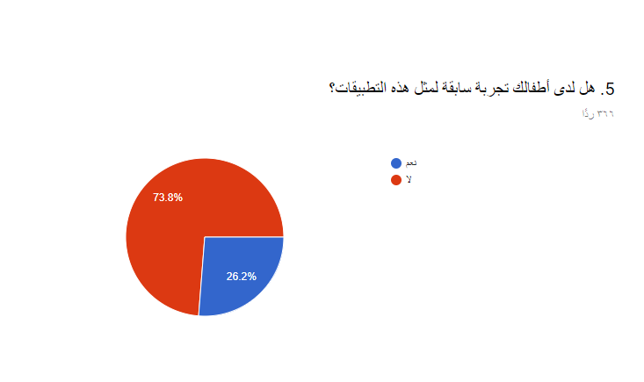

**2.2.4 Some Audience suggestions**

6. هل لديك أي اقتراحات؟

* جعل التطبيق على جميع أنواع أنظمة تشغيل الجوالات
* أن التطبيق يتوفر فيه لغتين اللغة العربية والإنجليزية
* أن يكون فعال ولا يقتصر فقط على الحيوانات بل الأحرف الهجائية والأرقام والأشكال
* أن يكون من ضمن التطبيق توضع معلومات عن هذا الحيوان إما بالكتابة أو الأفضل التحدث صوتياً أين يعيش ومن أية فئات وكم عمره
* تحديد عمر الأطفال المستهدفين
* إضافة فوائد هذه الحيوانات للبيئة والبشر وأماكن معيشتها
* لابد من تثقيف المجتمع وإنارة بصيرتهم على الجوانب المشرقة للتكنولوجيا وإعطاء الطفل الحق في اكتشاف كل ما هو جديد ومفيد له

**2.3 Literature Review:**

### **2.3.1 FETCH! Lunch Rush – an augmented reality math game:**

Is a neat use of augmented reality to create a mathematics lesson for young students. The free iPhone app (it also worked on my iPad 2) was developed by PBS Kids. The purpose of the app is to get kids moving about a room in search of numbers that are the correct answer to the questions posed to them on the app. Students read the arithmetic problem on the app then search out the correct answer. When they think they have found the correct answer they scan it with their iPhone or iPad to find out if they are correct or not.[3]

**2.3.2 Quiver – 3D coloring app:**

Given smartphones are more tailored for adults than adolescents, the staggering dearth of AR content for children isn’t exactly surprising. Thankfully, Quiver (formerly known as ColAR Mix) works to bring your child’s 2D color books to life with animated images that spring directly from the Crayola-lined pages upon your kitchen table. Although the app requires printed color pages, users can download one of several free coloring packs on the Quiver’s website, each of which encompasses everything from fire-breathing dragons and cuddly teddy bears, to towering dinosaurs and wild stallions. Once drawn, users merely need to ensure the entirety of the page is viewable within their smartphone camera’s peripheral, thus allowing the image to come to life with the drawn details and accompanying music. Users can watch the animations from any angle once started, pause the content, or even zoom in and out as if viewing a real-life object — and despite being geared toward children — there’s no denying it’s a bit of fun for all ages. [4]

### 

### **2.3.3 Zoo Burst app - 3D Storybooks with extra Augmented Reality:**

This is a nifty augmented reality app to help elementary level students learn through visual imaging. With this app, students get to interact and become a part of a story. ZooBurst allows you to engage in digital storytelling by designing storybooks complete with 3-D characters.

The digital storybooks can be customized using a library of thousands of images and users can add Adobe flash animations, narrations, and speech balloons to the story. Once the book is completed, students can become a part of the story via webcam. They can also click on the characters in the story to learn more about them.

The digital storybook created by ZooBurst can be rotated enabling you to view it from any angle. ZooBurst can also be used to help students create presentations and communicate complex ideas which would otherwise be difficult to explain. [5].

## **Comparison of Related Works**

Table 2.1 shows a brief comparison between our proposed system with existing related works. Table 2.1 Comparison with related works and our proposed project.

|  |  |  |  |  |
| --- | --- | --- | --- | --- |
| **App**  **Function** | **FETCH! Lunch Rush** | **Quiver – 3D** | **Zoo Burst app -3D** | **Our App** |
| **type** | **ios** | **ios** | **Ios** | **ios** |
| **free** | **Yes** | **Yes** | **Yes** | **Yes** |
| **For who** | **Any user specially for kids** | **Any user specially children** | **Any user wants to make a story book or presentation.** | **Kids** |
| **domain** | **Learn kids simple calculation processes.** | **This app for fun because , the user just focus the camera on 2D picture , then the app colors it and presents 3D content.** | **For any person has interest in presentation , or a kid can make his story book** | **For Kids to know and learn names of animals , their sounds , shape of them** |
| **Feature detection** | **yes** | **Yes** | **Yes** | **yes** |

# 

# **Table 2.2 comparing table of related apps with ours**

* 1. **Activity plan:**

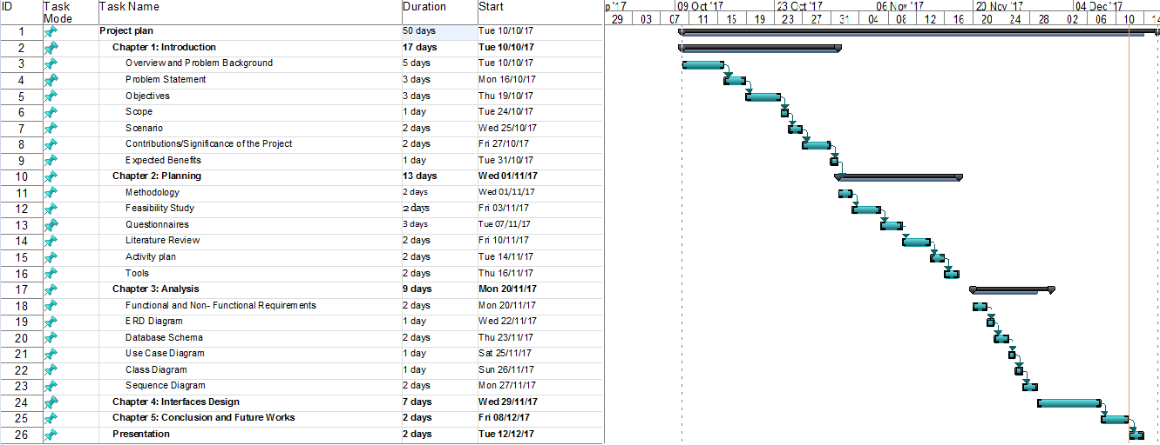Shows the detailed activity plan for our project in one academic year starting from analysis phase and ending with the testing and evaluation phase**.**

**Figure 2.2 Activity plan**

## **2.5 Tools:**

**2.5.1 Software Tools:**

* **2.5.1.1 Vuforia :**

There are several approaches to making Augmented Reality apps. We will be using a marker-based approach for making our AR app for mobile devices

Marker/Image Target – this is an image, which is recognized and tracked by a mobile device’s camera. This acts as an origin for augmentation. Once recognized, content can be displayed with respect to it.

Vuforia is one of the most popular platforms to help you work with augmented reality development.

Supported platforms: Android, iOS, UWP and Unity Editor.

The software implements the following functionalities: recognition of the different types of visual objects (a box, cylinder, and plane), text and environments recognition, VuMark (a combination of picture and QR-code). Also, using Vuforia Object Scanner, you can scan and create object targets. The recognition process can be implemented using the database (local or cloud storage). Unity plugin is simple to integrate and very powerful.[7].

* **2.5.1.2 Unity 3D :**

Unity 3D is a game engine and authoring environment for 2D and 3D interactive experiences.

If you are not familiar with any of the programming languages above, it will be much more efficient to dive into Unity 3D. It allows you to code in C# backed by the .Net framework (well, its open source cousin called mono).

This provides a good API, and Unity 3D allows you to publish the same code to Android, iOS, and PC without much modification.

Of course, handling a 3D engine and authoring environment has its very own challenges, but all in all, it will still be much more efficient to learn Unity 3D than to learn Objective-C/Xcode and Java/Android Studio at the same time.

Note: you will always need Xcode and an Apple Developer Program account, even if you use Unity 3D. [8]

* 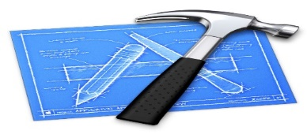**2.5.1.3 Xcode:**

Xcode is an [integrated development environment](https://en.wikipedia.org/wiki/Integrated_development_environment)  for [macOS](https://en.wikipedia.org/wiki/MacOS) containing a suite of [software development](https://en.wikipedia.org/wiki/Software_development) tools developed by [Apple](https://en.wikipedia.org/wiki/Apple_Inc.) for developing

software for macOS, [iOS](https://en.wikipedia.org/wiki/IOS), [watchOS](https://en.wikipedia.org/wiki/WatchOS)and [tvOS](https://en.wikipedia.org/wiki/TvOS). First released in 2003, the latest stable release is version 9.0 and is available via the [Mac App Store](https://en.wikipedia.org/wiki/Mac_App_Store) free of charge for [macOS Sierra](https://en.wikipedia.org/wiki/MacOS_Sierra) users. [Registered developers](https://en.wikipedia.org/wiki/Mac_Developer_Program) can download [preview releases](https://en.wikipedia.org/wiki/Software_release_life_cycle) and prior versions of the suite through the [Apple Developer](https://en.wikipedia.org/wiki/Apple_Developer) website.[9]

* **2.5.1.4 Visual paradigm v10.00:**



Visual Paradigm is a great, cross-platform and easy-to-use design and management tool for IT systems. it enables software developers to build quality applications faster, better because You can draw all kinds of UML diagrams in Visual Paradigm's [UML tools](https://www.visual-paradigm.com/features/uml-and-sysml-tools/). We used this tool for drawing all analysis diagrams of our app.[10]

**2.5.2 Hardware**

* **Mobile Devices:** mobiles needed for testing the final mobile application release before uploading it to Google play store online, testing stage in real mobile devices is important especially in payment process, to make sure it is working well.

**Chapter 3: Analysis**

# **Chapter 3: Analysis**

## **3.1 Functional and Non- Functional Requirements:**

Our project uses technologies for processing 2D photos and recognizing the animals , then shows the 3D model of them , our app works itself through AR technology & Unity 3D . There are two actors in this project:

The main user (kid) who uses the app to learn the names, shapes and sounds of the animals.

Admin who continues updating & controlling the database (set of photos for animals).

### **User Requirements:**

**3.1.1 Functional requirement**

**ID: FR1**

TITLE: sign up in the app

DESCRIPTION: the user should sign up in the app through email , password , age and gender.

RAT: In order for users to sign up in the app.

DEP: None

**Functional requirement**

**ID: FR2**

TITLE: sign in in the app

DESCRIPTION: the user should sign in through email and password.

RAT: In order for users to sign in into the app.

DEP: FR1

**Functional requirement:**

**ID: FR3**

TITLE: Open camera through the app and focuses on a 2D photo.

DESCRIPTION: the user should open the camera that track each frame..

RAT: In order for users to open the camera.

DEP: FR2

**Functional requirement**

**ID: FR4**

TITLE: Show the 3D photo of the animal being in the 2D photo with its name and sound

DESCRIPTION: The system should be able to handle and process the photo in accurate and fast way. After the system has a match between the 2D photo and the similar one in the database , the system shows 3D photo of the animal with playing the sound of it and says the name of the animal , then the system automatically adds this 3D animals in user's list.

RAT: In order to show the user the 3D photo and its sound .

DEP: FR3

**Functional requirement**

**ID: FR5**

TITLE: Clicks on the 3D photo for rotating it.

DESCRIPTION: After the system displays the 3D animal with its sound and says its name , the user can click on the 3D photo to rotate the animal.

RAT: In order to enable the user to rotate the 3D animal .

DEP: FR4

**Functional requirement**

**ID: FR6**

TITLE: Show list of latest shown animals

DESCRIPTION: any time the user can display his last shown animal photos.

RAT: In order to enable the user to show his last shown 3D animal photos. .

DEP: FR2

**Functional requirement**

**ID: FR7**

TITLE: shows the explanation of the movements within the app

DESCRIPTION: After signing in at the first time , it is displayed only one time.

DEP: FR2

### **Admin Requirements:**

**Functional requirement**

**ID: FR1**

TITLE: adding new 2D animals photos

DESCRIPTION: any time the admin can add 2D animal photos to the database of the app

RAT: In order to enable the admin to add new photos of animals his last shown 3D animal photos. .

DEP: None

**Functional requirement**

**ID: FR2**

TITLE: training the code on these new photos

DESCRIPTION: after adding new animals photos in the database

RAT: In order to enable the admin to train the code for the new photos.

DEP: FR1

**Functional requirement**

**ID: FR3**

TITLE: adding sounds

DESCRIPTION: after adding new animals photos in the database

RAT: In order to enable the admin to add sounds of the animals of the new photos.

DEP: FR1

### **3.1.2 Non- Functional Requirements:**

Non-functional requirements are descriptions of other features, characteristics, and limitations.

1. Ease of use: so that our system is effective and fast performance without delay or boredom by the user and not be difficult to the user through:
   * The system should be easy to use.
2. Security and reliability: In our system, we have:
   * Protection against DOS attacks by temporarily blocking any IP that issues a specific number of requests within one-second time.
   * There are security programs (antivirus) to protect the database.
   * The system must be automatically restored from any sudden failure within a maximum of 5 minutes.
   * A backup of the system. Monthly.
3. Capacity and durability: Our system must be able to work on all platforms and to respond to all requests and not to delay in their treatment and that is through:
   * Support most versions of iPhone.

## **3.2 ERD Diagram (Entity Relationship Diagram):**

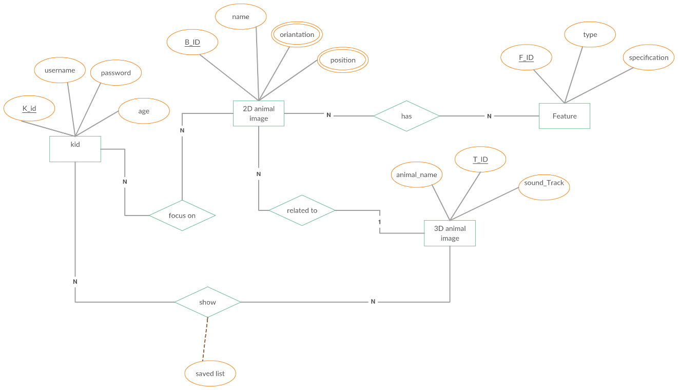An entity relationship diagram (ERD) shows the relationships of entity sets:

**Figure 3.1 ERD Diagram**

## **3.3 Database Schema**

**Figure 3.2 Database Schema**

## **3.4 Use Case Diagram:**

**3.4.1 Kid and Admin Use Case Diagram:**

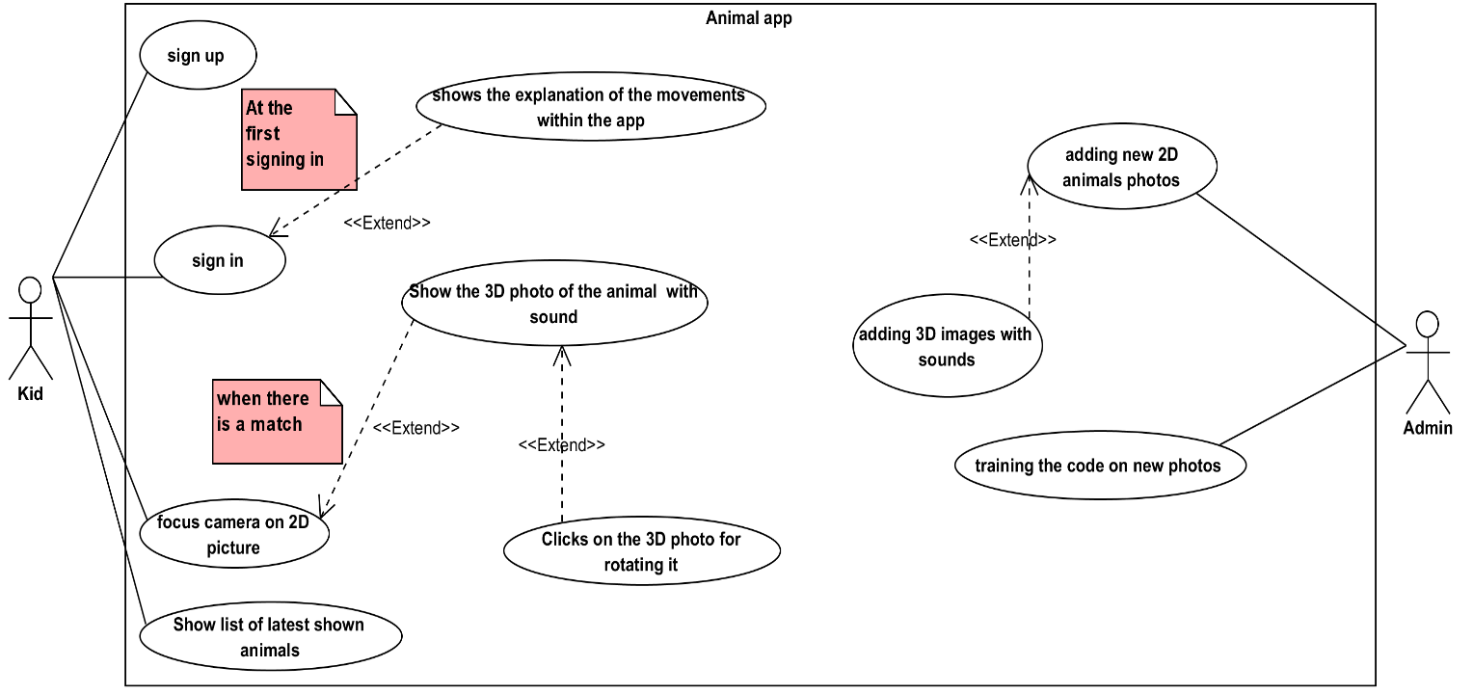Use case diagrams are usually referred to as [behavior diagrams](http://www.uml-diagrams.org/uml-25-diagrams.html#behavior-diagram) used to describe a set of actions ([use cases](http://www.uml-diagrams.org/use-case.html)) that some system or systems ([subject](http://www.uml-diagrams.org/use-case-subject.html)) should or can perform in collaboration with one or more external users of the system ([actors](http://www.uml-diagrams.org/use-case-actor.html)). Each use case should provide some observable and valuable result to the actors or other stakeholders of the system

**Figure 3.3 Use case Diagram**

### **3.4.2 Use Case Description:**

|  |  |
| --- | --- |
| Name: | sign up |
| Actor | Kid |
| Input conditions: | When the kid uses the app at the first time. |
| Flow of Events: | 1. Open the app . 2. Click on sign up 3. The system returns a sign up form 4. The kid fills the form and click submit 5. If the inputs correct the app adds the kid to database 6. Else go to 3 |
| Output Conditions: | The app return the kid to sign in form. |

Table 3.1: Sign up Use Case

|  |  |
| --- | --- |
| Name: | sign in |
| Actor | Kid |
| Input conditions: | When the kid wants to enter the app. |
| Flow of Events: | 1. The kid fills the signing in form 2. Click on sign in 3. The system compare input with database 4. If the kid is really existed then the system directs him to the home page 5. Else go to 1 |
| Output Conditions: | The system directs him to the home page |

Table 3.2: Sign in Use Case

|  |  |
| --- | --- |
| Name: | focus camera on 2D picture |
| Actor | Kid |
| Input conditions: | When the kid wants to know the animal in the picture |
| Flow of Events: | 1. The kid open the camera 2. He focuses the camera on the 2D photo 3. The system compares this 2D image with the target images in the database 4. If there is a match with any one in the database the system will display the 3D photo of the animal. 5. Else go to 2 |
| Output Conditions: | Show the 3D photo of the animal with sound |

Table 3.3: focus camera on 2D picture

|  |  |
| --- | --- |
| Name: | Show the 3D photo of the animal with sound |
| Actor | Kid |
| Input conditions: | When the kid focuses the camera on a 2D photo , and the system had got a match with it in the database |
| Flow of Events: | 1. The kid shows the 3D photo on the 2D photo , with playing the sound track of the animal. 2. The system keeps displaying the 3D photo until the kid takes away the camera from the 2D picture. |
| Output Conditions: | Show the 3D photo of the animal with sound |

Table 3.4: Show 3D photo of Animal

|  |  |
| --- | --- |
| Name: | Clicks on the 3D photo for rotating it |
| Actor | Kid |
| Input conditions: | Show the 3D photo of the animal with sound |
| Flow of Events: | 1. While the system the 3D photo , the kid can click on the 3D animal photo 2. Then the system rotates the 3D animal . |
| Output Conditions: | This action continues until the kid takes the camera from the 2D photo. |

Table 3.5: Clicks on the 3D photo for rotating it

|  |  |
| --- | --- |
| Name: | Show list of latest shown animals |
| Actor | Kid |
| Input conditions: | Any time when the kid enters the app |
| Flow of Events: | 1. The kid clicks on "last animals" 2. The system displays a list of the last animals shown by the kid. |
| Output Conditions: | The system displays the last animals shown by the kid |

Table 3.6: Show list of latest shown animals

|  |  |
| --- | --- |
| Name: | adding new 2D animals photos |
| Actor | Admin |
| Input conditions: | Any time the admin can add new 2D animals photos in the database |
| Flow of Events: | 1. The admin has got the full control , so he can select many new 2D animals image 2. Enters them to the system which processes those photos , and determines the highlights points into them. |
| Output Conditions: | adding 3D images with sounds |

|  |  |
| --- | --- |
| Name: | adding 3D images with sounds |
| Actor | Admin |
| Input conditions: | adding new 2D animals photos |
| Flow of Events: | 1. The admin adds 3D images with sound tracks 2. The system connects the 2D images with these 3D images & sound tracks. |
| Output Conditions: | The 3D images & sound tracks saved into the database |

Table 3.7: Adding new 2D animal's photo

Table 3.8: Adding 3D images with sound

|  |  |
| --- | --- |
| Name: | training the code on new photos |
| Actor | Admin |
| Input conditions: | After adding the 2D & 3d images with the appropriate sound tracks. |
| Flow of Events: | 1. The admin trains the code for those 2D & 3D images 2. After the training process is done , the system can recognize any 2D animal photo with the database. |
| Output Conditions: | The system is ready to work for the new 2D images |

Table 3.9: Training the code on new photos

## 

## 

## **3.5 Class Diagram:**

Class diagram in the [Unified Modeling Language](https://en.wikipedia.org/wiki/Unified_Modeling_Language) (UML) is a type of static structure diagram that describes the structure of a system by showing the system's [classes](https://en.wikipedia.org/wiki/Class_(computer_science)), their attributes, operations (or methods), and the relationships among objects.

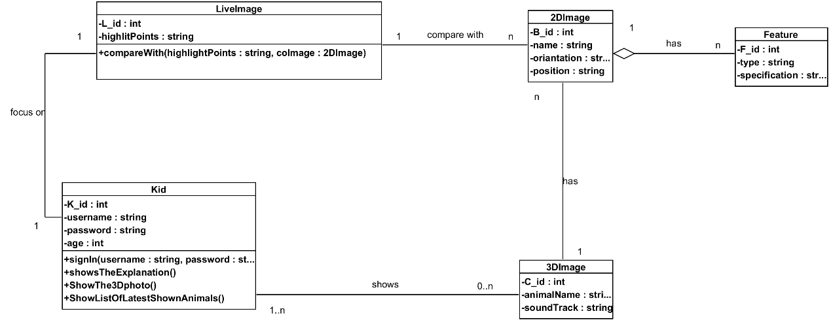The purpose of class diagram is to model the static view of an application. Class diagrams are the only diagrams which can be directly mapped with object-oriented languages and thus widely used at the time of construction.

**Figure 3.4 Class Diagram**

## 

## **3.6 Sequence Diagram**

# Sequence diagrams are a popular dynamic modeling solution. Dynamic modeling focuses on the interactions occurring within the system. Sequence diagrams specifically focus on the "lifelines" of an object and how they communicate with other objects to perform a function before the lifeline ends.

# **C:\Users\TARCOM-HP\Desktop\AR\اللعبة\diagrams\مخططات\sign in kidnew.png3.6.1 Kid sign in:**

**Figure 3.5 Kid sign in diagram**

# **3.6.2 Show 3D animal:**

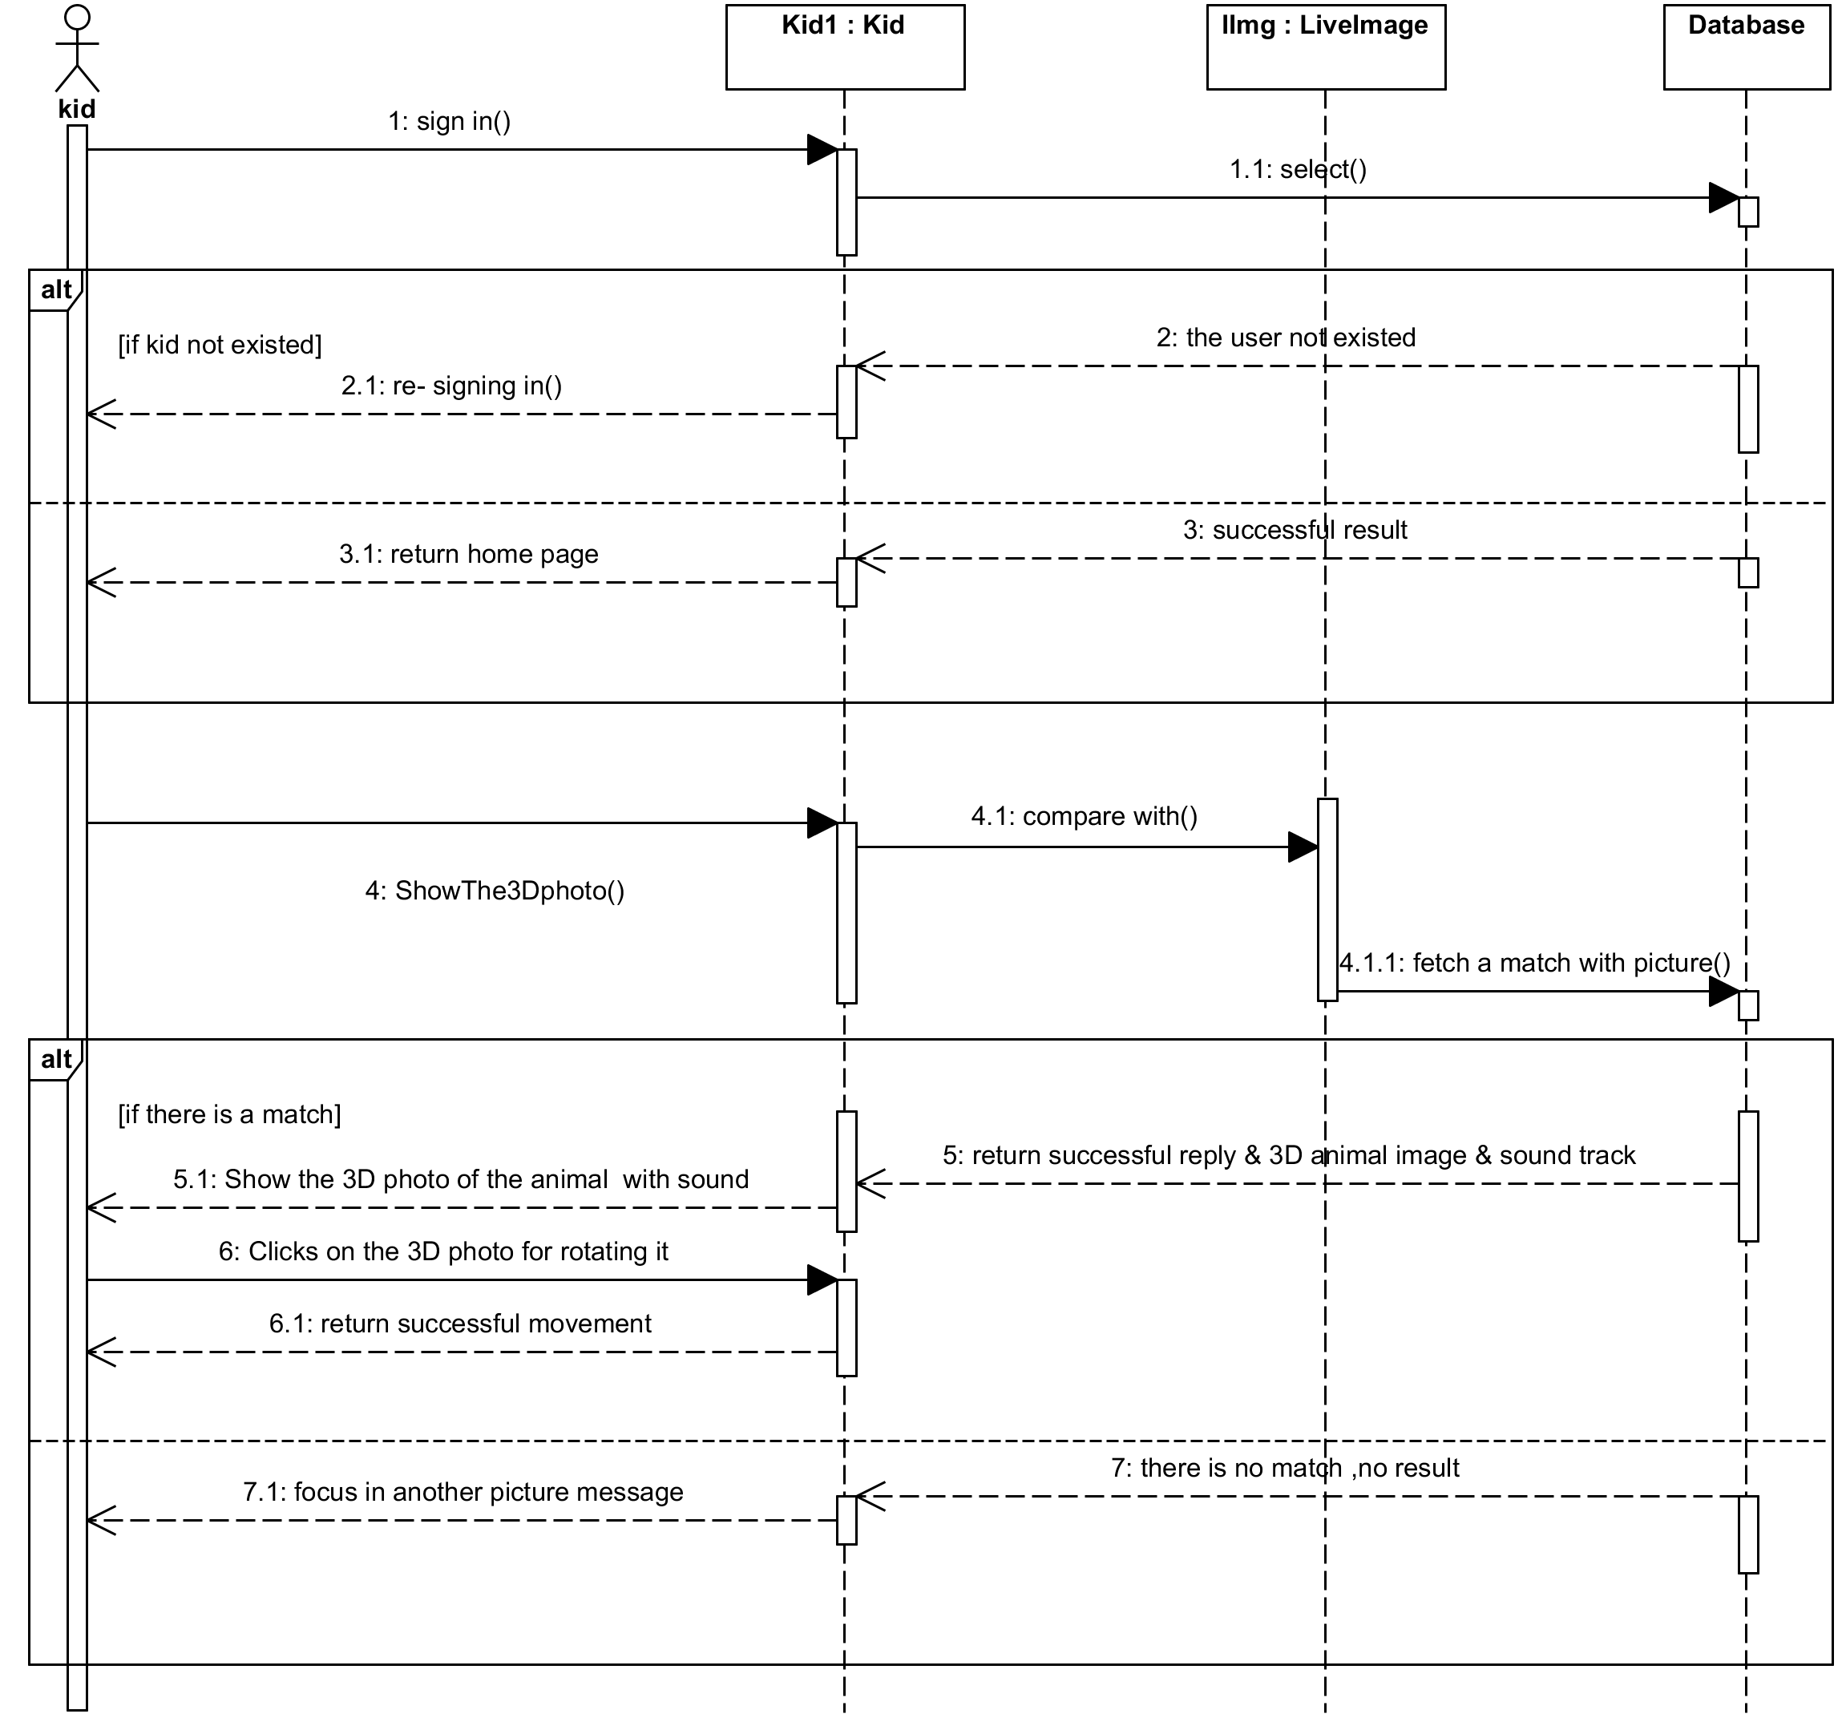

**Figure 3.6 show 3D animal diagram**

# **C:\Users\TARCOM-HP\Desktop\AR\اللعبة\diagrams\مخططات\show list shown animalsnew.png3.6.3 Show list of shown animals:**

**Figure 3.7 show list of shown animal's diagram**

# 

# **3.6.4 Admin Tool:**

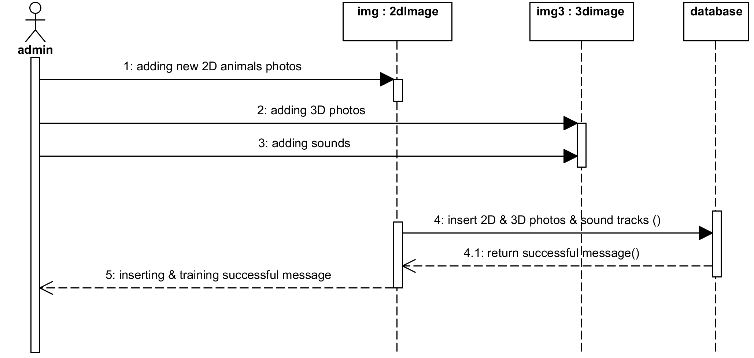

**Figure 3.8 admin Tool diagram**

**Chapter 4: Interfaces Design**

# **Chapter 4: Interfaces Design**

## **4.1 User Interfaces:**

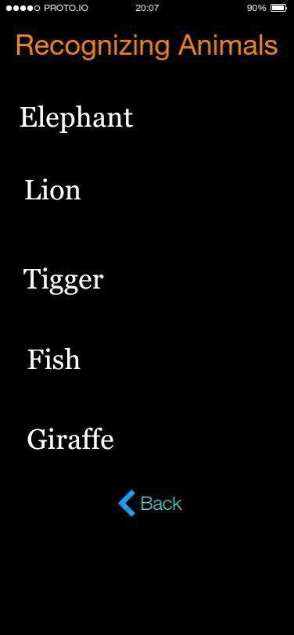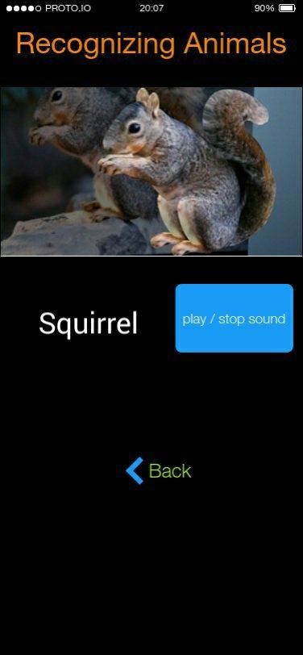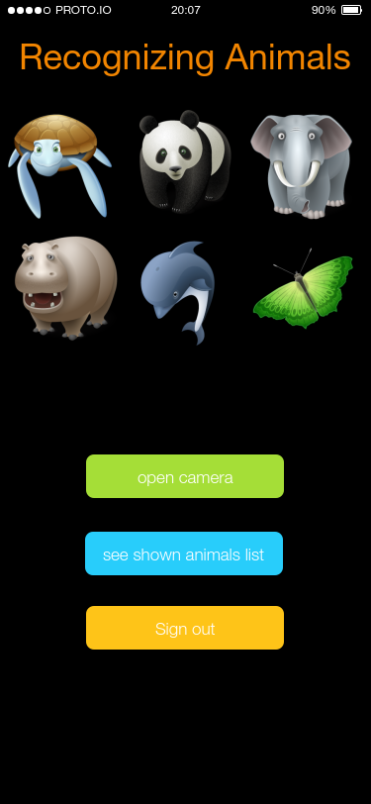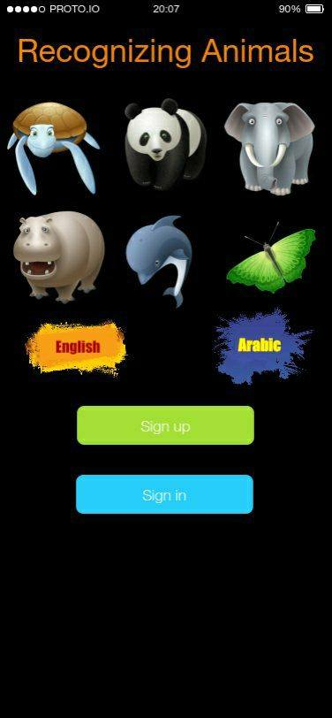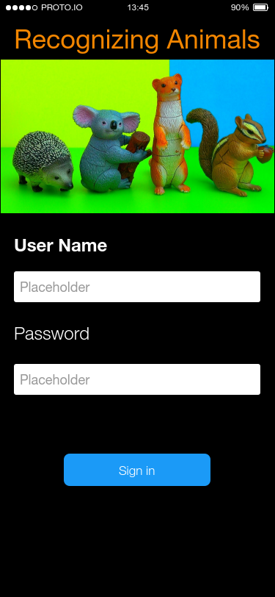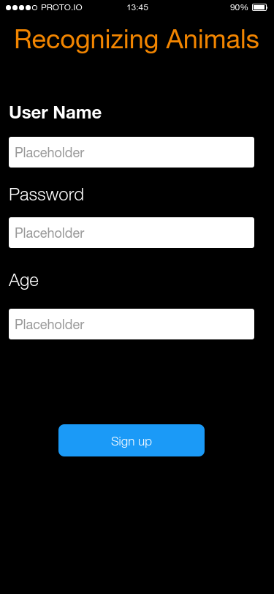

**Figure 4.1 User Interfaces**

**Chapter 5: Conclusion and future works**

# 

# 

# **Chapter 5 Conclusion and Future Works:**

## **5.1 Conclusions:**

# At this point, we designed an initial system (an application) on smart phones to learn kids the names of the animals and their voices in a assuming manner. Also, modeling the functional requirements of the system by converting them into understandable diagrams. We also designed questionnaire and collected data to show if this application will help with educating kids. Our results were encouraging.

## **5.2 Future Works:**

# Next main Steps of the project:

# Programming a mobile application for the proposed system using IOS platform.

# Testing the resulting app if that achieved the requirements.

# Finally write final report, conclusion and future recommendations for our app

# **References**:

[1] “What is Augmented Reality (AR)_ Ultimate Guide to Augmented Reality (AR) Technology.” [Online]. Available: http://www.realitytechnologies.com/augmented-reality .

[2] “Augmented reality - Wikipedia.” [Online]. Available: https://en.wikipedia.org/wiki/Augmented_reality.

[3] “Free Technology for Teachers_ Fetch! Lunch Rush! - An Augmented Reality Math Game.” [Online]. Available: http://www.freetech4teachers.com/2012/09/fetch-lunch-rush-augmented-reality-math.html#.WevkAOMwTIV.

[4] “The 20 Best Augmented-Reality Apps _ Page 2 _ Digital Trends.” [Online]. Available: https://www.digitaltrends.com/mobile/best-augmented-reality-apps/2/.

[5] “5 Top Augmented Reality Apps for Education - Hongkiat.” [Online]. Available: https://www.hongkiat.com/blog/augmented-reality-apps-for-education/.

[6] “Waterfall model - Wikipedia.” [Online]. Available: https://en.wikipedia.org/wiki/Waterfall_model.

[7] “10 best augmented reality sdk for ar development in 2017.” [Online]. Available: https://thinkmobiles.com/blog/best-ar-sdk-review/.

[8] “Create Your First Augmented Reality Experience Using the Programming Language You Already Know _ PACKT Books.” [Online]. Available: https://www.packtpub.com/books/content/create-your-first-augmented-reality-experience-using-programming-language-you-already-.

[9] “Xcode - Wikipedia.” [Online]. Available: https://en.wikipedia.org/wiki/Xcode.

[10] “Visual Paradigm - Leading UML, BPMN, EA, Agile and Project Management Software.” [Online]. Available: https://www.visual-paradigm.com.

[11] Questionnaire in English: https://docs.google.com/forms/d/e/1FAIpQLSc1HIm7Pw_QYTJaqoGfu5wsg0mkxOeNw96oCIuhiw0gGSaGDA/viewform?c=0&w=1

[12] Questionnaire in Arabic: https://docs.google.com/forms/d/e/1FAIpQLScMZdhOYg4K5b-GWa_J13-w37xDvWfC5qF0gqyy8fVE_Ce_KQ/viewform